Ideation Phase
Brainstorm & Idea Prioritization Template

Date | 31 January 2026
Team ID | LTVIP2026TMIDS73502
Project Name | Rising Waters: A Machine Learning Approach to Flood Prediction
Maximum Marks | 4 Marks

Step-1: Team Gathering, Collaboration and Select the Problem Statement
Discussion Summary:
Floods are one of the most devastating natural disasters causing:
- Loss of human lives
- Agricultural damage
- Infrastructure destruction
- Economic instability
Traditional flood warning systems:
- Are reactive rather than predictive
- Do not use real-time data efficiently
- Lack accuracy in local-level forecasting
Selected Problem Statement:
“To develop an intelligent machine learning-based flood prediction system that analyzes historical and real-time environmental data to provide early flood warnings.”
Why This Problem?
- Increasing climate change effects
- Rising frequency of extreme rainfall events
- Need for accurate and early disaster alerts
- Helps government & communities prepare in advance

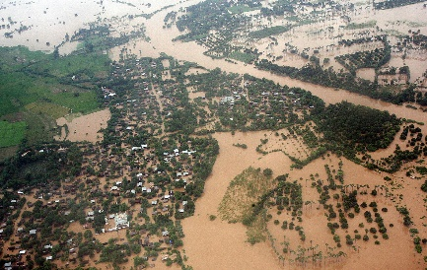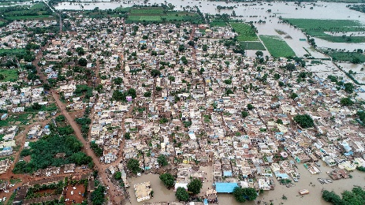

Step-2: Brainstorm, Idea Listing and Grouping
Brainstormed Ideas
- Use rainfall prediction models
- Use river water level sensors
- Analyze satellite imagery
- Weather forecast data integration
- Real-time IoT-based monitoring
- SMS alert system for villagers
- Mobile app for flood alerts
- AI-based disaster risk scoring
- Historical flood data analysis
- GIS mapping integration

Idea Grouping
Category | Ideas
Data Collection | Rainfall data, river levels, satellite images
Technology | Machine Learning models (Random Forest, LSTM)
Alert System | SMS alerts, mobile app notifications
Visualization | GIS flood maps, risk heatmaps
Deployment | Government integration, Cloud-based dashboard

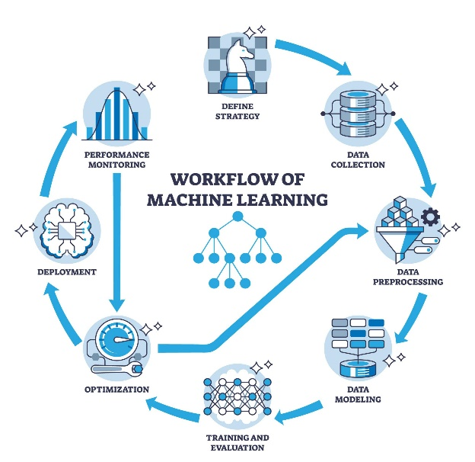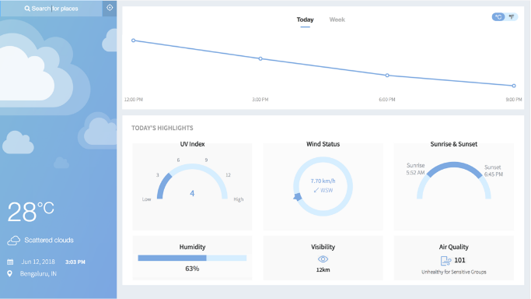
Step-3: Idea Prioritization
Evaluation Criteria
- Feasibility
- Impact
- Innovation
- Scalability
- Cost-effectiveness

Prioritized Final Solution
Selected Idea:
Develop a Machine Learning-based Flood Prediction Model using:
- Historical rainfall data
- River water levels
- Humidity & temperature data
- Real-time weather API data
Proposed ML Models:
- Random Forest
- Logistic Regression
- LSTM (for time-series forecasting)

Final Solution Summary
“Rising Waters” is a predictive analytics platform that:
- Collects real-time environmental data
- Uses ML algorithms to predict flood probability
- Sends early alerts via SMS & Mobile App
- Provides dashboard visualization for authorities

